SMART CRADLE SYSTEM

A PROJECT REPORT

Submitted by

SANJAY S M | 71762205104
SWETHA G | 71762205118
TAMIL SELVAN D | 71762205119

BACHELOR OF ENGINEERING
in

COMPUTER SCIENCE AND ENGINEERING

COIMBATORE INSTITUTE OF TECHNOLOGY
(Government Aided Autonomous Institution Affiliated to Anna University)
COIMBATORE-641014
ANNA UNIVERSITY: CHENNAI 600 025

MAY 2025

TABLE OF CONTENTS

CHAPTER NO. |  | TITLE | PAGE NO.
1 |  | PROBLEM STATEMENT | 1
2 |  | COMPONENTS REQUIRED | 2
 |  | 2.1 SOFTWARE | 2
 |  | 2.2 HARDWARE | 2
3 |  | ARCHITECTURE / CIRCUIT DIAGRAM | 5
 |  | 3.1 SYSTEM ARCHITECTURE | 5
 |  | 3.2 WORKING PRINCIPLE | 5
 |  | 3.3 CIRCUIT DIAGRAM | 6
 |  | 3.4 CONNECTION CONFIGURATION | 7
4 |  | SOURCE CODE | 8
5 |  | RESULT | 10
 |  | 5.1 RESULT SCREENSHOT | 10

- PROBLEM STATEMENT

In today’s fast-paced world, many parents struggle to provide constant attention and care to their infants due to work commitments, stress, or lack of support systems. Traditional cradles lack the intelligence to respond to a baby’s needs, often requiring the caregiver’s presence for monitoring, soothing, or managing environmental factors like heat and humidity.

One of the primary concerns in infant care is the inability to immediately respond when a baby cries or when the surrounding environment becomes unsuitable, such as high humidity or temperature. These issues can lead to discomfort, disrupted sleep, or even health problems in infants. Furthermore, in nuclear families or when only one parent is available, the lack of real-time monitoring and responsive systems significantly increases the stress and workload of caregiving.

A Smart Cradle System, incorporating Internet of Things (IoT) technology, can bridge this gap. Such a system can automate cradle rocking when the baby cries, activate a fan when humidity is high, and send real-time alerts via WiFi to the parents’ devices.
Automatically rocks the cradle when the baby cries and controls humidity with a fan for optimal comfort.

Sends real-time alerts to parents via WiFi, enabling remote monitoring and timely responses. The system uses an Arduino Uno microcontroller to monitor the baby's environment and actions, while the ESP8266 module enables real-time communication over WiFi. The sound and humidity sensors detect crying and environmental conditions, while the relay module controls a DC motor to rock the cradle and a fan to regulate humidity.
- COMPONENTS REQUIRED
2.1 SOFTWARE
The Smart integrates both hardware and software components to visualize environment, real-time data processing of room temperature, humidity, and user interaction.
2.1.1 Software Components
A) Arduino IDE
The Arduino IDE (Integrated Development Environment) is used to write, compile, and upload code to the Arduino Uno microcontroller. It supports a simplified C/C++ programming language, It also allows real-time code uploading and testing, ensuring smooth integration of all hardware components.
B) Blynk IoT
Blynk IoT is a platform that allows real-time monitoring and control of IoT devices through a smartphone application. It connects the Arduino Uno to the cloud using the ESP8266 WiFi module. With Blynk, users can view sensor data and control devices like the fan or motor remotely.
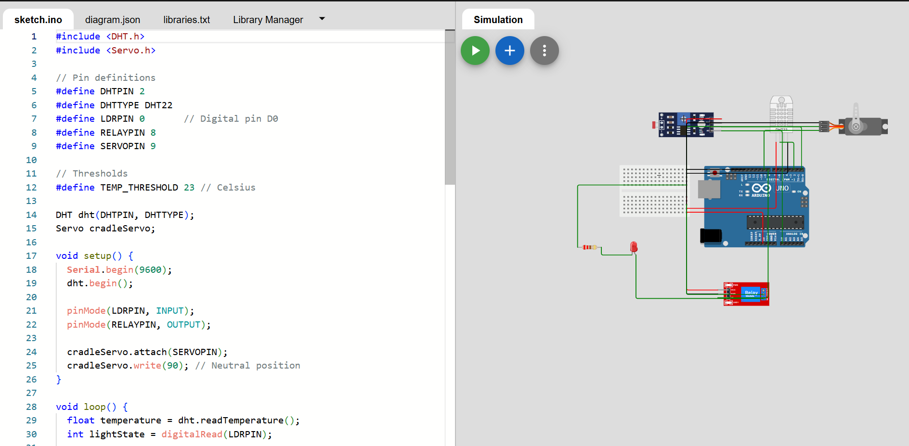

2.2 HARDWARE
The successful implementation of the Smart Shopping Trolley with Automated Billing relies on the integration of various electronic components, sensors, and communication modules
    - Hardware Components
A) Arduino
- Arduino is an open-source microcontroller platform used for building electronic projects.
- It can read inputs (like sensor signals) and control outputs (like motors, LEDs, pumps). Arduino boards are programmed using the Arduino IDE with a simplified version of C/C++.
- It's beginner-friendly and widely used in DIY projects, robotics, and automation.

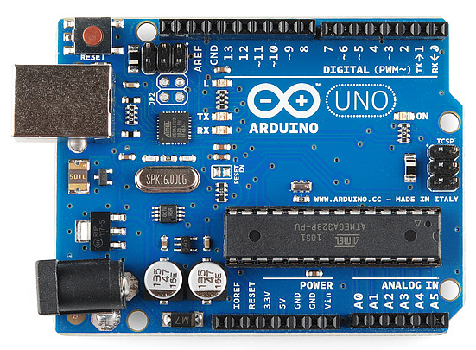
B) Servo motor
- Provides gentle back-and-forth movement of the cradle.
- Simulates the natural rocking motion to soothe a crying baby.
- Controlled automatically based on sound sensor input.
- Arduino sends PWM (Pulse Width Modulation) signals to the servo.
- Servo rotates to specific angles as instructed.
- For rocking, it alternates between set angles to create smooth motion.
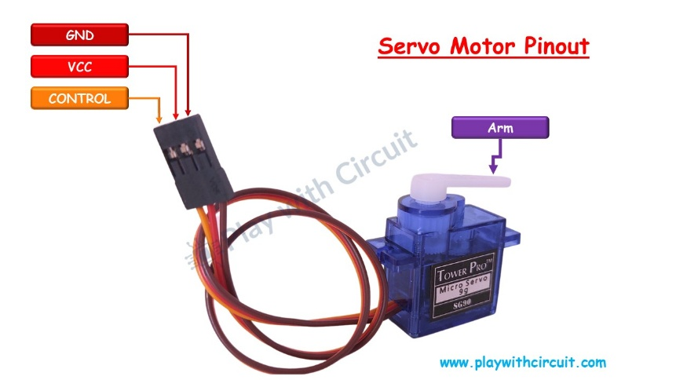
C) Sound sensor
- Detects baby's cry through ambient sound.
- Triggers the servo motor to rock the cradle automatically.
- Converts sound waves into analog voltage signals.
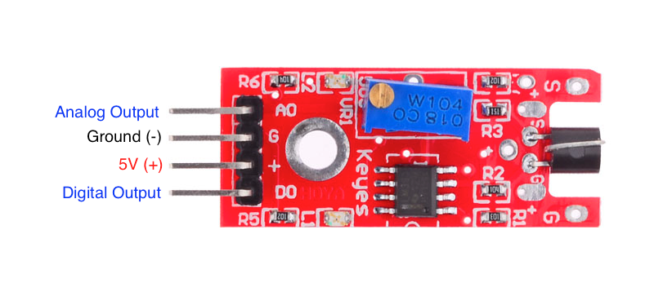
- Arduino reads the signal through an analog pin (e.g., A0).
- If the signal crosses a threshold (e.g., baby cry volume), it activates the rocking mechanism.

E) Temperature
- The temperature sensor is used to monitor the baby's environment and ensure it's comfortable. If the temperature exceeds a safe limit, it automatically turns on a fan (or alert) to maintain a suitable condition..
- It contains a humidity sensor (capacitive type) and a thermistor to measure temperature.
- An internal 8-bit microcontroller processes the analog signals and sends calibrated digitaldata.
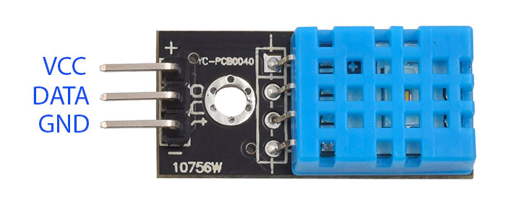

3.ARCHITECTURE DIAGRAM

  - SYSTEM ARCHITECTURE
The system architecture consists of an Arduino Uno connected to a DHT11 sensor for temperature and humidity sensing and a sound sensor for cry detection. A servo motor rocks the cradle based on the crying level detected. The Arduino reads sensor data, processes conditions, and actuates the cradle via the servo. All components are powered through the Arduino, with real-time monitoring via the Serial Monitor.

  - WORKING PRINCIPLE

The Smart Cradle System is an automated baby-soothing and environment-monitoring device built using Arduino. It combines multiple sensors and actuators to detect a baby's cry, rock the cradle accordingly, and monitor ambient temperature and humidity.

3.2.1 Step-by-Step Functionality

1. Cry Detection
A sound sensor module continuously monitors sound intensity levels near the cradle. When the analog sound level exceeds a predefined threshold (set based on testing), the system interprets it as a baby’s cry. The Arduino processes this input by comparing it against the threshold (e.g., CRY_THRESHOLD = 20) to determine the presence of crying.

2. Cradle Movement (Servo Motor)
If a cry is detected, the system activates a servo motor to rock the cradle. The motor performs a series of back-and-forth swings:
- From the center (90°) to the right (150°),
- Then to the left (0°),
- And returns to center,
- Repeating this cycle for 10 seconds.
This gentle rocking motion mimics manual soothing by a caregiver and aims to calm the baby.

3. Environment Monitoring (DHT11 Sensor)
The DHT11 sensor measures the temperature and humidity inside the cradle's surroundings. These values are read periodically and can be:
- Displayed on the Serial Monitor,
- Used for logging or decision-making (e.g., alerts if temperature is too high/low).

4. Data Communication
While the current system removes NodeMCU, the Arduino still logs the data via the Serial Monitor, displaying:
- Current temperature (°C),
- Humidity (%),
- Cry status (detected or not),
- Raw sound sensor value.
This data helps in assessing the baby's comfort level and the cradle’s environment over time.
  - CIRCUIT DIAGRAM:

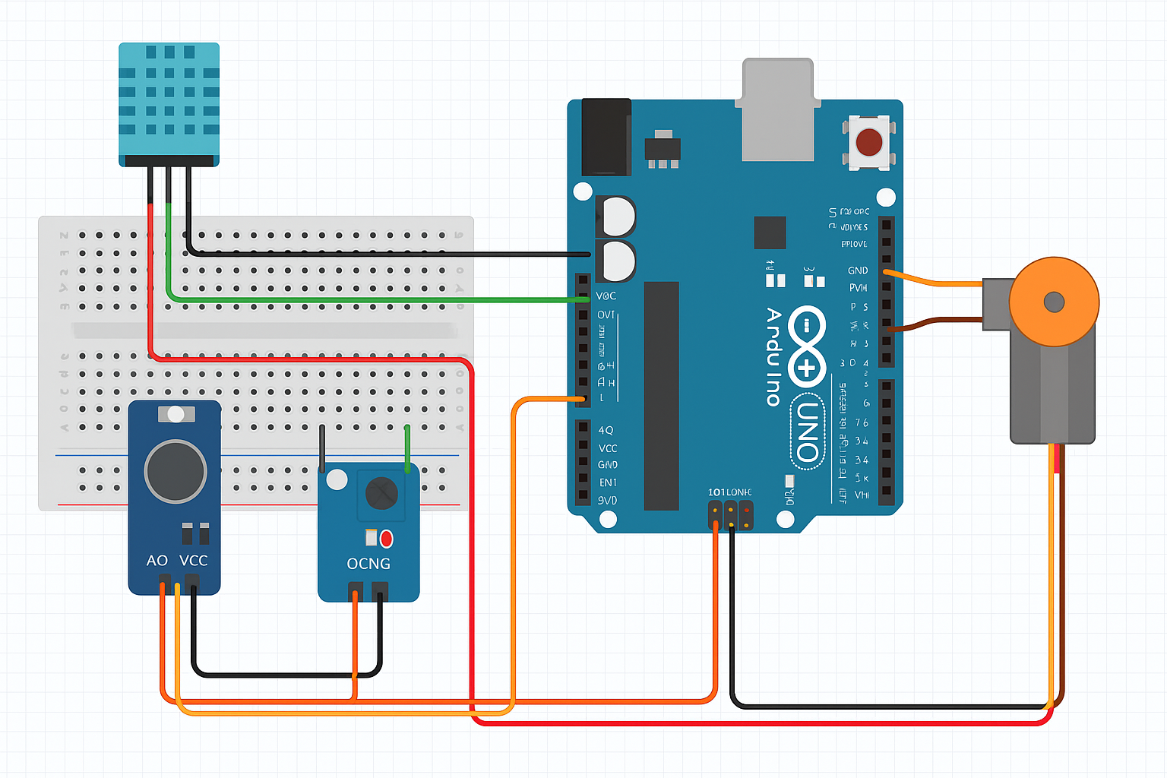

  - CONNECTION CONFIGURATION

1. DHT11 Sensor

DHT11 Pin | Connects To
VCC | 5V (Arduino )
GND | GND (Arduino)
DATA | Digital Pin 4

2.Sound Sensor

Sound Sensor Pin | Connects To
VCC | 5V (Arduino)
GND | GND (Arduino)
A0 (Analog Out) | A0 (Arduino)

3. Servo Motor

Servo Wire | Connects To
Red (VCC) | 5V (Arduino or external power source with GND common)
Brown/Black (GND) | GND (Arduino)
Orange/Yellow (Signal) | Digital Pin 5

4.SOURCE CODE

CODE:

#include <DHT.h>
#include <Servo.h>

#define DHTPIN 4
#define DHTTYPE DHT11
#define SOUND_SENSOR A0
#define SERVOPIN 5

DHT dht(DHTPIN, DHTTYPE);
Servo cradleServo;

// Threshold value for cry detection (tune this based on testing)
#define CRY_THRESHOLD 20
void setup() {
dht.begin();
cradleServo.attach(SERVOPIN);
pinMode(SOUND_SENSOR, INPUT);

Serial.begin(9600); // Serial Monitor

Serial.println("Smart Cradle System Started");
}

void loop() {
float temp = dht.readTemperature();
float hum = dht.readHumidity();
int soundLevel = analogRead(SOUND_SENSOR);

// Determine cry status
int cry = (soundLevel > CRY_THRESHOLD) ? 1 : 0;

// Print to Serial Monitor
Serial.print("Temp: ");
Serial.print(temp);
Serial.print(" C, Hum: ");
Serial.print(hum);
Serial.print(" %, Cry Level: ");
Serial.print(soundLevel);
Serial.print(" → Cry Detected: ");
Serial.println(cry);

// Rock cradle for 10 seconds if crying
if (cry == 1) {
unsigned long startTime = millis();
while (millis() - startTime < 10000) { // Run for 10 seconds
// Right swing
for (int pos = 90; pos <= 150; pos++) {
cradleServo.write(pos);
delay(10);
}
// Left swing
for (int pos = 150; pos >= 0; pos--) {
cradleServo.write(pos);
delay(10);
}
// Return to center
for (int pos = 0; pos <= 90; pos++) {
cradleServo.write(pos);
delay(10);
}
}
} else {
delay(5000);
cradleServo.write(90); // Neutral position

5.RESULTS

  - RESULT SCREENSHOT

